
ARCHITECTURE DESIGN ASSIGNMENT
Intelligent Airport Baggage Tracking and Logistics Management Platform
CSA1016-SOFTWARE ENGINEERING

Name: K.Arthika Reddy
Regno:192373033
Department:CSE(DS)

1. Analyze System Requirements
1.1 System Objectives
Airports handle thousands of passengers and baggage items every day. Managing baggage efficiently is one of the biggest challenges faced by airport authorities. Delayed, misplaced, or lost baggage leads to passenger dissatisfaction, operational delays, and increased costs for airlines. The Intelligent Airport Baggage Tracking and Logistics Management Platform is designed to overcome these challenges by integrating Artificial Intelligence (AI), Internet of Things (IoT), RFID technology, GPS, and cloud computing.
The system continuously monitors baggage movement from the check-in counter until baggage claim. RFID tags attached to each baggage item allow real-time tracking throughout the airport. AI algorithms analyze baggage movement patterns to predict delays, identify possible routing errors, and recommend corrective actions before problems occur.
Passengers can monitor the exact location and current status of their baggage through a mobile application or web portal. Airport staff receive instant alerts whenever baggage is delayed, misplaced, or requires manual inspection. Administrators gain access to detailed reports and dashboards that help improve airport operations and baggage logistics.
The primary objective is to create a secure, reliable, scalable, and intelligent baggage management platform that minimizes baggage loss, improves operational efficiency, reduces waiting time, and enhances the overall passenger experience.
Objectives
- Provide real-time baggage tracking from check-in to baggage claim.
- Reduce baggage loss, theft, and mishandling.
- Improve baggage handling efficiency through automation.
- Predict baggage delays using Artificial Intelligence.
- Optimize baggage routing inside airports.
- Notify passengers about baggage status updates.
- Improve airport logistics management.
- Generate reports for airport administrators.
- Enhance passenger satisfaction.
- Support multiple airports and airline operations.

1.2 Functional Requirements
The system provides several functional features that support baggage management and airport logistics.
Passenger Registration
Passengers create secure accounts using their personal information and verify their identity before accessing baggage services.
Passenger Login
Registered users log into the platform securely using username/password or biometric authentication.
Flight Information Management
The system stores and manages flight schedules, departure gates, arrival gates, delays, and airline information.
Baggage Registration
Every baggage item is registered during check-in and assigned a unique RFID tag and QR code for identification.
RFID Tracking
RFID readers installed across airport terminals continuously detect baggage movement and update its location in real time.
QR Code Verification
Airport staff can scan QR codes to verify baggage ownership during transfer and baggage claim.
Smart Baggage Routing
The platform automatically determines the most efficient conveyor belt and routing path for baggage based on flight schedules.
AI-Based Delay Prediction
Machine Learning algorithms analyze historical baggage movement and current airport conditions to predict baggage delays.
Lost Baggage Detection
If baggage remains stationary for an abnormal period or deviates from its planned route, the system immediately identifies it as potentially misplaced.
Passenger Notifications
Passengers receive instant SMS, email, or mobile app notifications regarding baggage status, delays, transfers, and baggage arrival.
Airport Staff Dashboard
Airport staff can monitor baggage movement, identify delayed baggage, and manually intervene whenever necessary.
Administrator Dashboard
Airport administrators monitor system performance, baggage statistics, flight performance, and airport logistics.
Report Generation
The system generates operational reports including:
- Delayed baggage reports
- Lost baggage reports
- Daily baggage movement
- Flight baggage statistics
- Airport performance reports

1.3 Non-Functional Requirements
The platform should satisfy several quality requirements.
Performance
The system must process thousands of RFID scans every minute while maintaining response times below two seconds.
Scalability
The architecture should support multiple airports, airlines, and millions of baggage records without affecting system performance.
Security
Passenger information and baggage records should be protected using authentication, authorization, encryption, and secure communication protocols.
Reliability
The platform should continuously monitor baggage without interruptions and maintain highly accurate tracking information.
Availability
The application should remain operational 24 hours a day throughout the year.
Maintainability
The modular architecture should simplify software updates and maintenance activities.
Usability
The user interface should be simple, responsive, and easy to use for passengers and airport staff.
Data Privacy
Passenger personal information should comply with international privacy standards.

1.4 Quality Attributes
Quality Attribute | Description
Scalability | Supports thousands of concurrent passengers, flights, and baggage items.
Performance | Processes RFID data with minimum latency.
Reliability | Ensures accurate baggage tracking with minimal failures.
Availability | Operates continuously throughout airport working hours.
Security | Encrypts passenger and baggage information.
Maintainability | Modular design simplifies upgrades and debugging.
Interoperability | Integrates easily with airline and airport systems.
Flexibility | Supports future expansion and new airport technologies.

2. Selected Software Architecture
Layered (Three-Tier Architecture)

Architecture Layers
Presentation Layer
Provides interfaces for:
- Passenger Mobile Application
- Airport Staff Portal
- Administrator Dashboard
- Airline Management Portal

Business Logic Layer
Responsible for
- Authentication
- Flight Management
- Baggage Registration
- RFID Tracking
- AI Prediction
- Smart Routing
- Notifications
- Report Generation
- Security Management

Data Layer
Stores
- Passenger Information
- Flight Information
- Airline Data
- RFID Logs
- Baggage Records
- Notification Logs
- Reports
- AI Prediction Results

Justification
The Layered Architecture separates the application into three independent layers, allowing developers to update the user interface without modifying the database. Business logic remains isolated, making the system easier to maintain, test, and expand.
This architecture is particularly suitable because airport systems involve numerous independent services such as flight management, baggage tracking, AI prediction, payment processing, and notifications. Each service can be maintained independently while sharing a common database.

3. Software Architecture Diagram
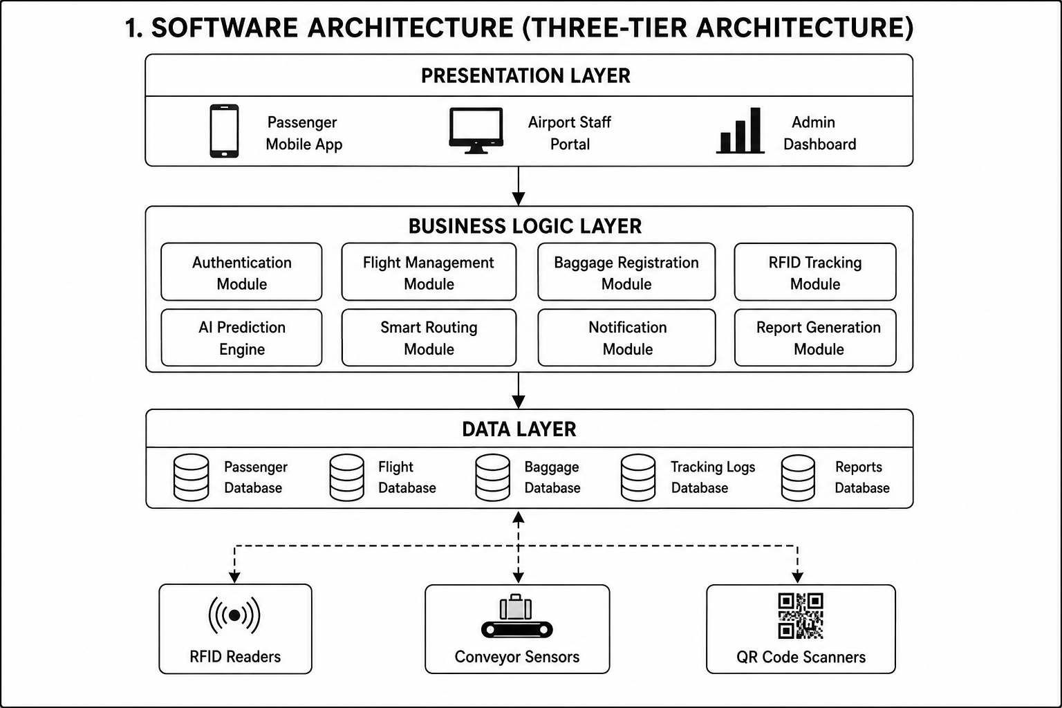

4. Components and Their Interactions
Presentation Layer
This layer provides graphical interfaces for passengers, airport staff, airlines, and administrators. Users can register, log in, monitor baggage status, receive notifications, and view reports.

Authentication Module
Verifies user identity before allowing access. It manages login credentials, user roles, password encryption, and session management.

Flight Management Module
Stores flight schedules, departure information, arrival times, airline details, and gate assignments.

Baggage Registration Module
Assigns RFID tags and QR codes to baggage during check-in and stores baggage information.

RFID Tracking Module
Receives data from RFID readers installed throughout the airport and updates baggage location continuously.

AI Prediction Engine
Uses Machine Learning algorithms to predict:
- Possible baggage delays
- Conveyor congestion
- Wrong baggage routing
- Missed flight connections

Notification Module
Sends
- SMS alerts
- Push notifications
- Email notifications
- Boarding reminders
- Baggage arrival notifications

Report Generation Module
Produces reports including:
- Daily baggage movement
- Delayed baggage statistics
- Lost baggage analysis
- Airline performance
- Airport efficiency
- Passenger complaints

Database Layer
Stores all operational data securely using MySQL.

External Hardware Components
RFID Readers
Installed at check-in counters, conveyor belts, transfer stations, aircraft loading areas, and baggage claim counters.
Conveyor Belt Sensors
Monitor baggage movement speed and detect congestion.
QR Code Scanners
Verify baggage ownership during baggage collection.
GPS Tracking
Tracks baggage transport vehicles operating between airport terminals.

Workflow
START
↓
Passenger Books Flight
↓
Passenger Checks In
↓
Baggage Registration
↓
RFID Tag Generated
↓
Baggage Moves Through Conveyor
↓
RFID Readers Detect Location
↓
AI Predicts Delay
↓
Correct Routing Suggested
↓
Airport Staff Receive Alert
↓
Passenger Receives Notification
↓
Aircraft Loading
↓
Arrival Airport Tracking
↓
Baggage Claim
↓
Passenger Collects Baggage
↓
Generate Reports
↓
END

5. Quality Attributes
Scalability
Supports millions of baggage transactions annually across multiple airports.
Security
Implements HTTPS, AES encryption, role-based authentication, secure APIs, and RFID verification.
Reliability
Maintains continuous baggage tracking even during heavy airport traffic.
Performance
Processes thousands of baggage events every second.
Maintainability
Layer separation allows developers to update one module without affecting others.
Availability
Designed for continuous 24×7 airport operation with backup servers and database replication.
Interoperability
Integrates with airline reservation systems, airport management systems, customs systems, and security checkpoints.

6. Architectural Decisions
Rationale
The Layered Three-Tier Architecture provides clear separation between presentation, business logic, and database management. This makes the application easier to develop, test, debug, and maintain. It also supports integration with RFID devices, AI services, cloud infrastructure, and airport management systems.

Trade-Offs
Advantages
- Highly modular architecture
- Easy maintenance
- Better scalability
- Supports cloud deployment
- Secure communication
- Easy integration with AI and IoT
- Simplified debugging
- Supports multiple airports
- High reliability
- Faster development
Disadvantages
- Increased communication between layers
- Slightly higher response time due to layered processing
- Initial deployment cost is higher
- Integration with airport hardware requires specialized infrastructure

Future Enhancements
- Blockchain-based baggage ownership verification
- AI-powered baggage damage detection
- Autonomous robotic baggage transport
- Drone-assisted baggage delivery within airports
- Predictive maintenance for conveyor systems
- Integration with international airline systems
- Voice-enabled passenger assistance
- Smart airport digital twin technology
- Cloud-native deployment with Kubernetes
- Multi-language support for global passengers
- Real-time airport analytics dashboard
- Carbon footprint monitoring for baggage logistics

